

Practices for Secure Software Report

Table of Contents
Document Revision History 3
Client 3
Instructions 3
Developer 4
1. Algorithm Cipher 4
2. Certificate Generation 4
3. Deploy Cipher 5
4. Secure Communications 5
5. Secondary Testing 5
6. Functional Testing 7
7. Summary 8
8. Industry Standard Best Practices 9

Document Revision History

Version | Date | Author | Comments
1.0 | 2/22/2026 | Shawn Stover | Completed

Client



Instructions

Submit this completed practices for secure software report. Replace the bracketed text with the relevant information. You must document your process for writing secure communications and refactoring code that complies with software security testing protocols.

- Respond to the steps outlined below and include your findings.
- Respond using your own words. You may also choose to include images or supporting materials. If you include them, make certain to insert them in all the relevant locations in the document.
- Refer to the Project Two Guidelines and Rubric for more detailed instructions about each section of the template.

Developer
Shawn Stover

Algorithm Cipher

SHA-256 paired with RSA provides a strong, modern, and standards-aligned encryption approach that fits Artemis Financial’s need for secure communication and reliable file verification. SHA-256 is a 256-bit cryptographic hash function that produces a fixed-length, collision-resistant digest, making it ideal for checksums and integrity validation during file transfers. RSA complements this by using an asymmetric keypair—a public key for encryption or signature verification and a private key for decryption or signing—allowing Artemis Financial to authenticate data sources and protect sensitive information without sharing secret keys. Together, SHA-256 and RSA ensure confidentiality, integrity, and authenticity: SHA-256 verifies that data has not been altered, while RSA enables secure key exchange and digital signatures. Both rely on cryptographically secure random number generation to produce unpredictable keys and maintain security strength. Historically, RSA, introduced in 1977, became the first widely adopted public-key cryptosystem and remains foundational in secure web communication, while SHA-256, introduced by NIST in 2001 as part of the SHA-2 family, replaced weaker predecessors like SHA-1. Today, SHA-256 with RSA is a core component of TLS certificates, digital signatures, and financial-grade security protocols, making it a reliable and industry-approved choice for Artemis Financial’s modernization efforts.

Certificate Generation
Insert a screenshot below of the CER file.

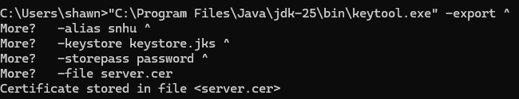

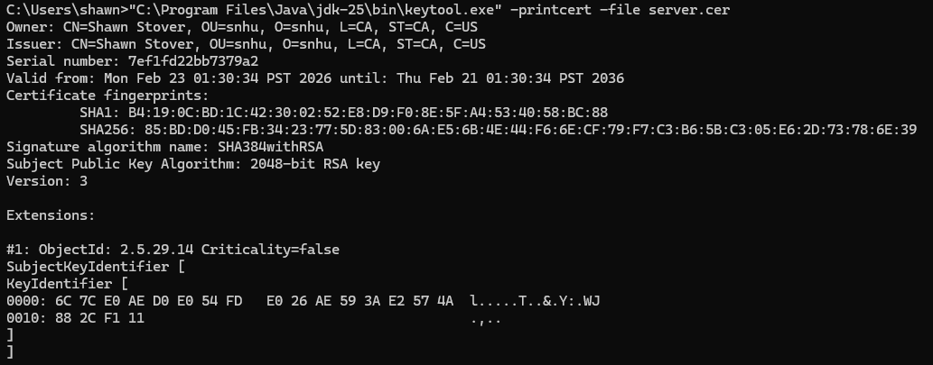

Deploy Cipher
Insert a screenshot below of the checksum verification.

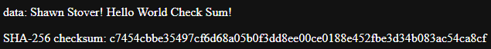

Secure Communications
Insert a screenshot below of the web browser that shows a secure webpage.

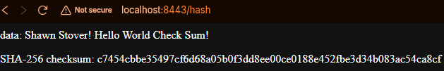

Secondary Testing
Insert screenshots below of the refactored code executed without errors and the dependency-check report.

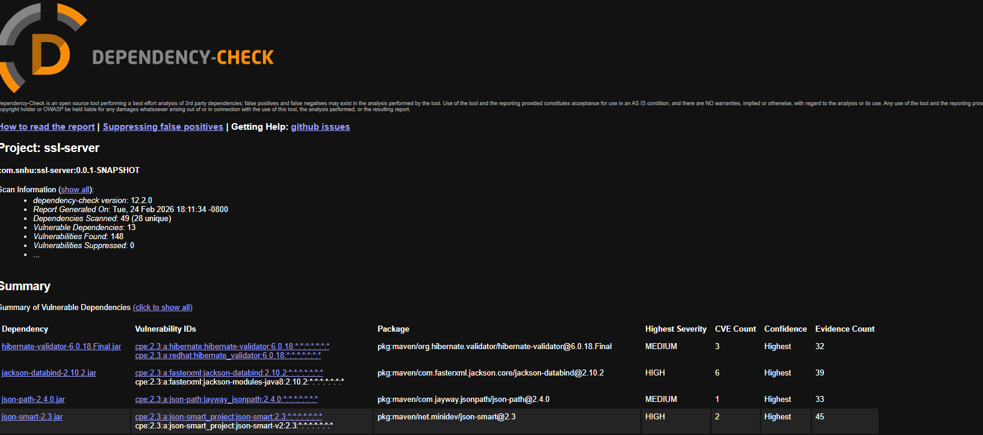

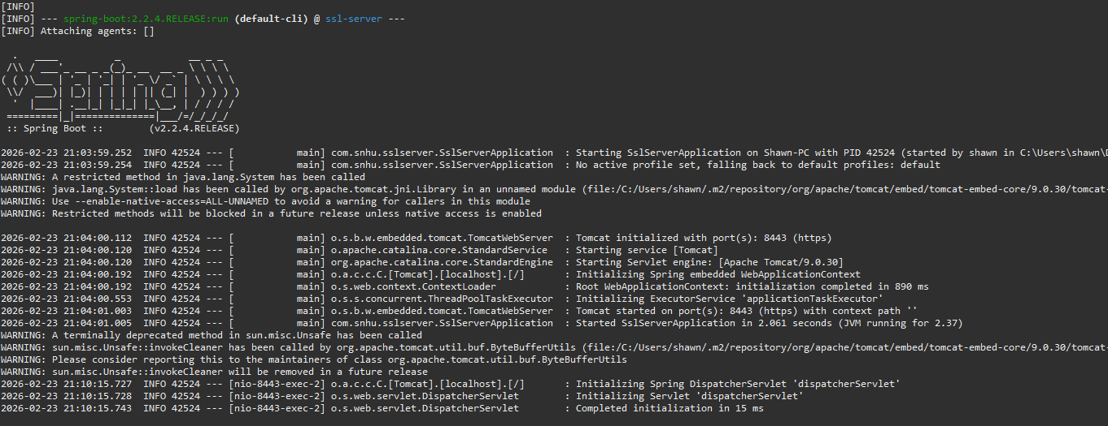

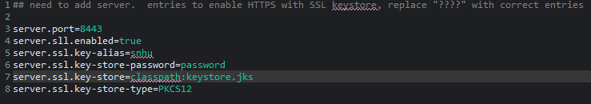

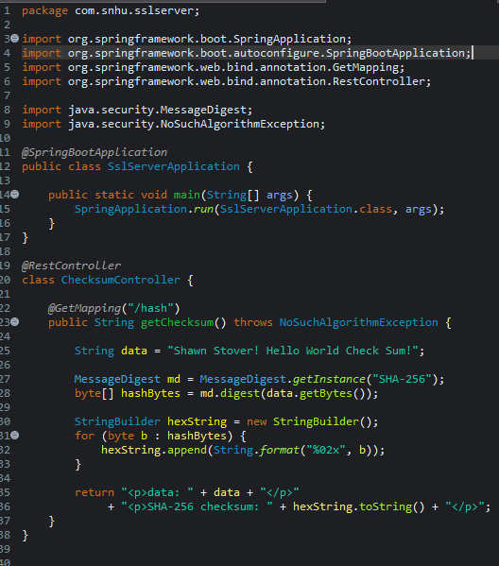

Functional Testing
Insert a screenshot below of the refactored code executed without errors.

Summary
Refactoring the application focused on the security areas highlighted in the first two levels of the vulnerability assessment process flow diagram: authentication and authorization, data validation, cryptography, configuration management, and error handling. The most significant change was the addition of a dedicated checksum endpoint that uses SHA-256, a modern, collision-resistant hashing algorithm. This directly addresses the “Cryptographic Security” area of the diagram by replacing insecure or missing hashing logic with a vetted, industry-standard algorithm.
The refactoring also strengthened configuration security by moving the keystore into the application’s classpath and referencing it through classpath: rather than an absolute file path. This prevents exposure of sensitive filesystem locations and ensures the application loads certificates in a controlled, predictable way. Additionally, the HTTPS configuration enforces encrypted transport, addressing the “Communication Security” area of the diagram and ensuring that the checksum data is not exposed in plaintext.
Finally, the project structure was corrected so that Eclipse and Maven both compile the application using a full JDK rather than a JRE. This aligns with the “Environment and Dependency Security” area of the diagram by ensuring the build environment uses secure, supported tooling and avoids misconfigurations that could introduce vulnerabilities.
The process of adding layers of security followed a deliberate, defense-in-depth approach consistent with the vulnerability assessment process flow. The first layer focused on securing the transport channel by enabling HTTPS and ensuring the server used a trusted keystore, which protects all subsequent interactions. The second layer added data-integrity protection through SHA-256 hashing, ensuring that the checksum endpoint produces trustworthy, tamper-resistant output. A third layer strengthened configuration security by eliminating hard-coded file paths and replacing them with classpath-based resource loading, reducing the risk of leaking system information or misplacing sensitive files. Finally, the environment layer ensured that the application compiled and ran using a full JDK with complete cryptographic libraries, preventing runtime failures and ensuring consistent, secure behavior across environments. Together, these layers demonstrate a structured, standards-aligned approach to secure software development that reduces vulnerabilities, improves reliability, and supports the company’s long-term security posture.

Industry Standard Best Practices
Industry-standard secure-coding practices were applied throughout the refactoring process to strengthen the application against known vulnerabilities while preserving its existing security posture. The use of SHA-256 hashing for the checksum endpoint reflects widely accepted cryptographic standards and ensures that the application handles integrity-critical data using a modern, collision-resistant algorithm. Enforcing HTTPS through a properly generated keystore maintains secure communication by ensuring all data transmitted between the client and server is encrypted, which aligns with best practices recommended by OWASP and NIST. Configuration security was also improved by loading the keystore from the classpath rather than relying on hard-coded file paths, reducing the risk of exposing sensitive system information and ensuring consistent, secure behavior across environments. Additionally, ensuring the project compiles with a full JDK rather than a JRE supports secure cryptographic operations and prevents runtime failures that could compromise the application’s reliability.
Applying these industry-standard practices contributes significantly to the company’s overall well-being. Strong cryptography, secure transport, and hardened configuration reduce the likelihood of data breaches, unauthorized access, and integrity failures—events that can lead to financial loss, legal liability, and reputational damage. Following secure-coding standards also lowers long-term maintenance costs by preventing vulnerabilities early in the development lifecycle, where they are easier and less expensive to fix. Consistent use of best practices demonstrates due diligence, supports regulatory compliance, and builds customer trust by showing that the organization prioritizes security. Ultimately, these practices create more resilient software, reduce operational risk, and strengthen the organization’s security culture, contributing to a more stable and trustworthy technology environment.

